1. Wirte a shell script to find the largest number among three numbers entered by the user

Code:

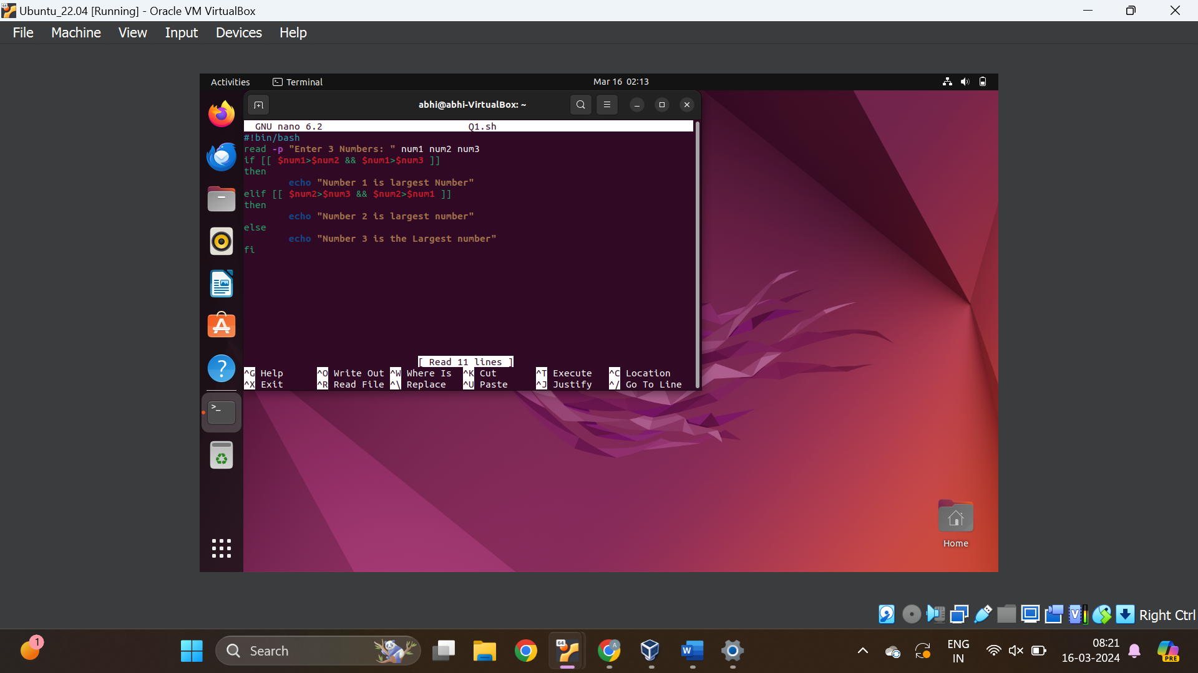

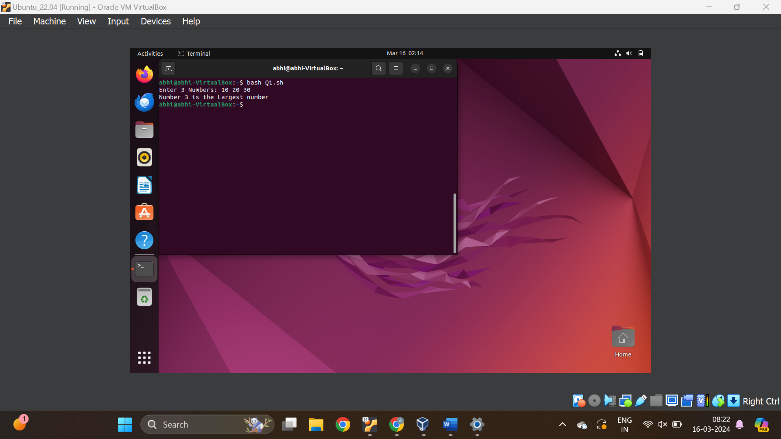

1. Create a linux Ec2 and access the ec2 through putty on your system. Conert this .pem file to .ppk file and then create a html page and make it available on a public IP address

Step1: Open Ec2 instance dashboard

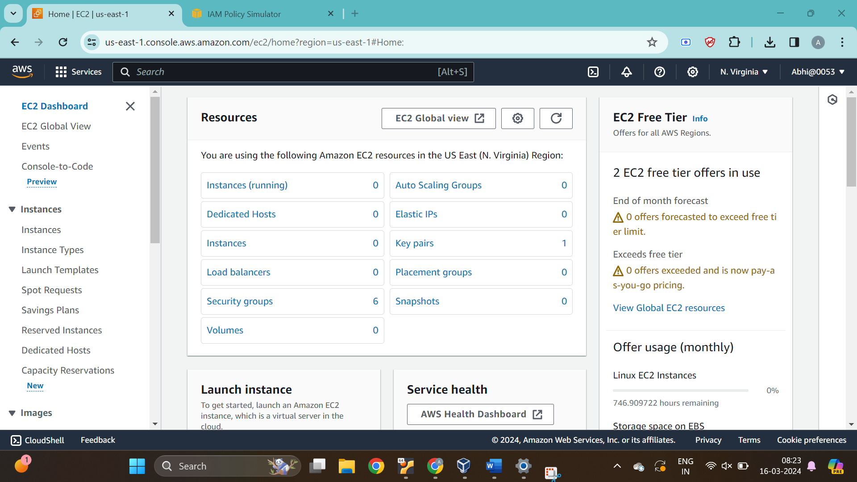

Step2: Click on launch Instance

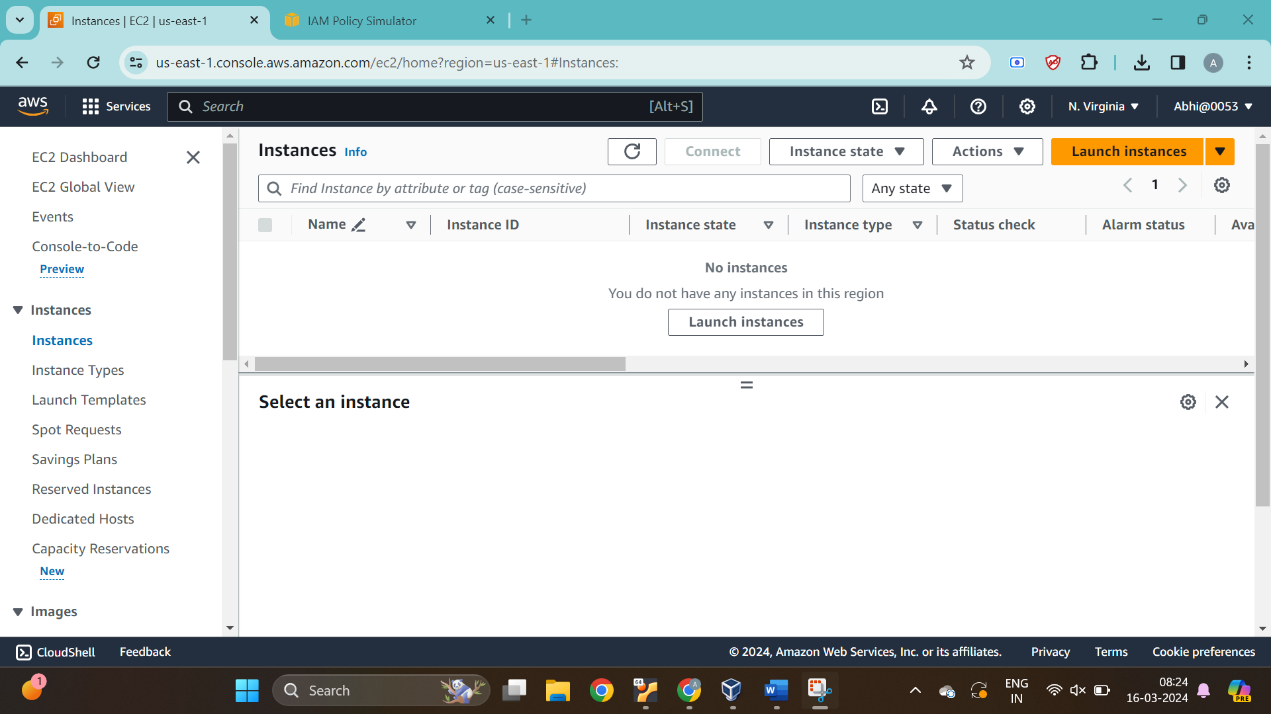

Step 3: Enter the Instance name

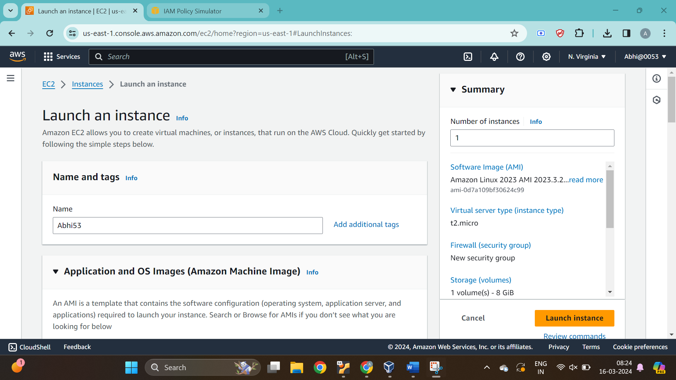

Step4: Select the key

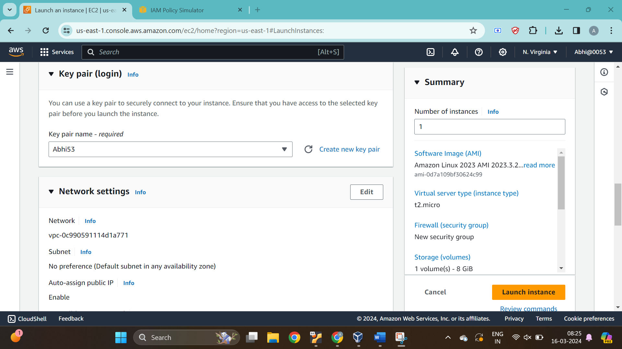

Step 5: Tick the allow https traffic from the internet & click on Launch instance

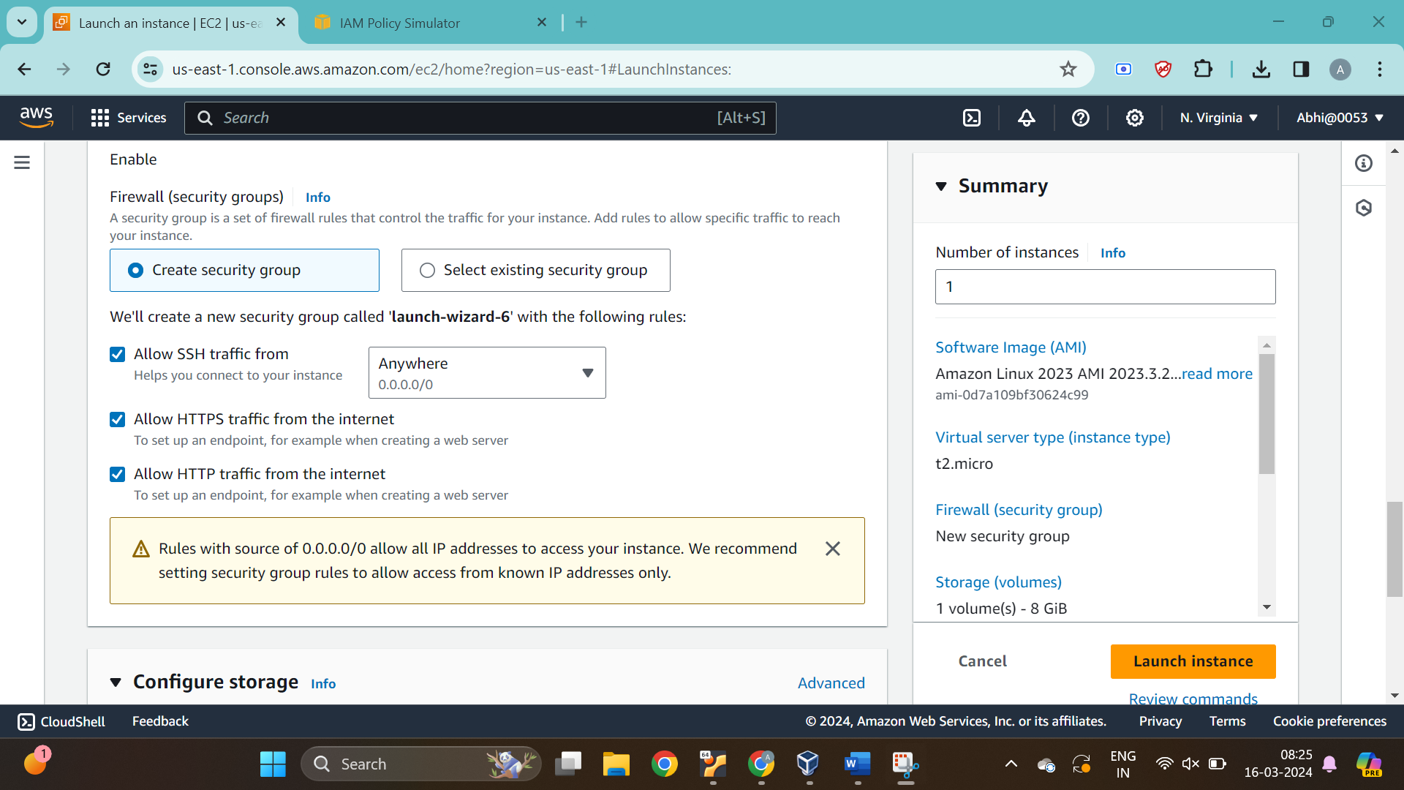

Step6: Click on instances

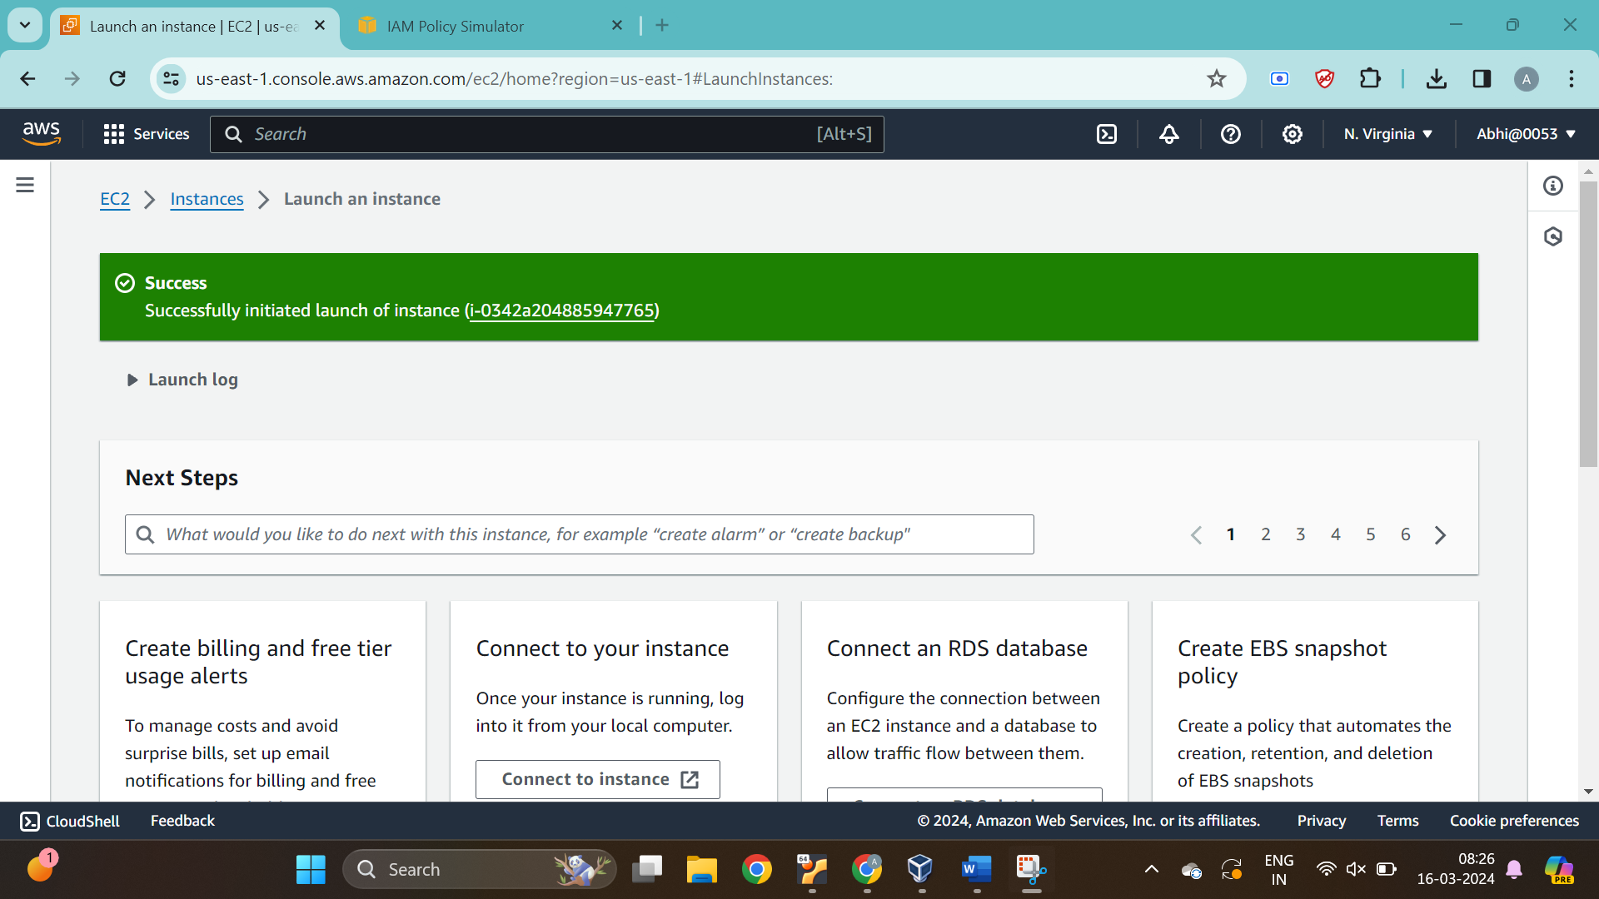

Step 7: Check the status of the instance

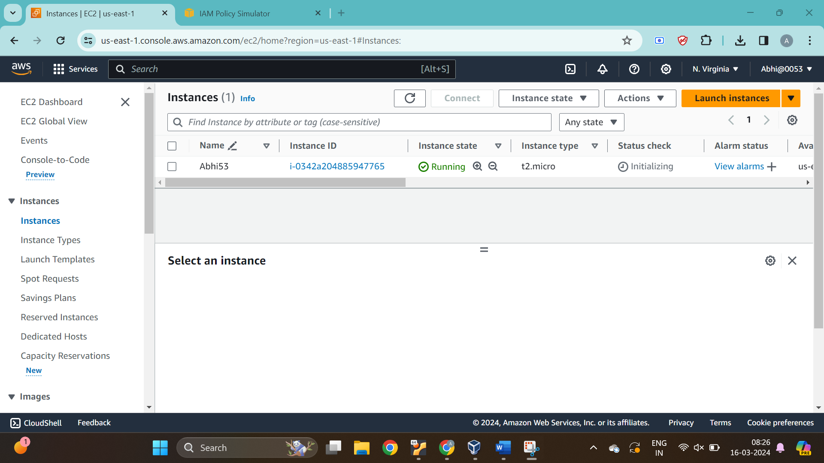

Step8: Open Putty

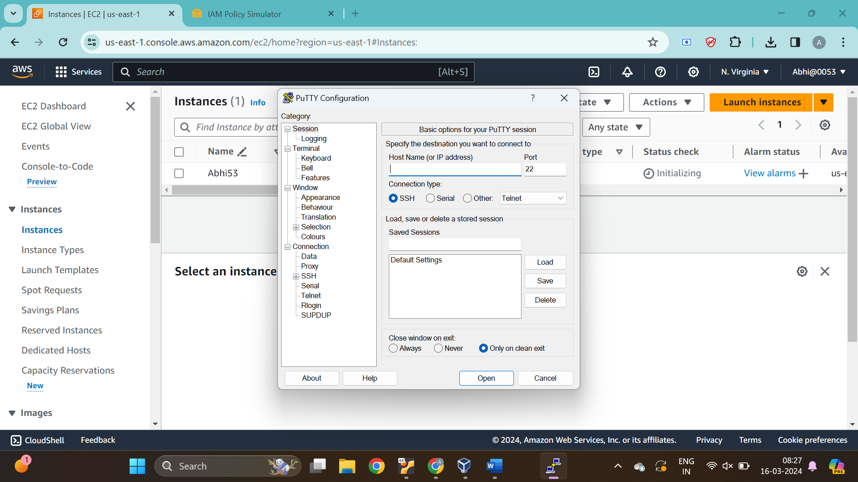

Step 9: Copy the Ipv4 address from the running Ec2 instance

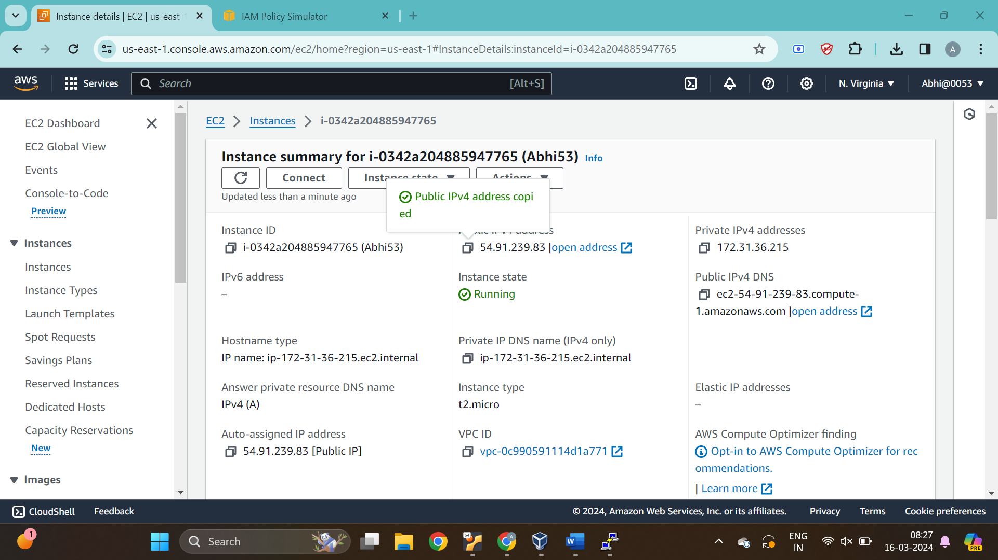

Step 10 : Enter a command “ec2-user@(ipaddress” to connect to that Ip address

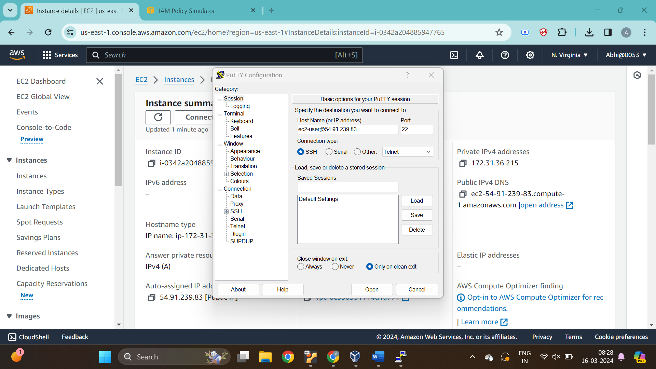

Step 11: Open Convection, then SSH, then Auth, And then Credentils

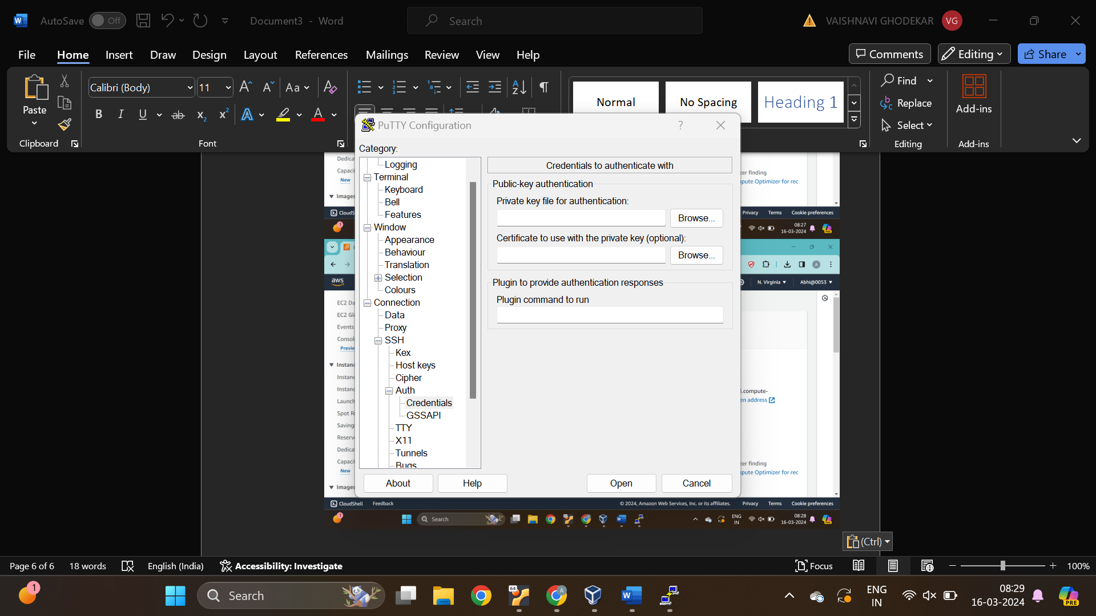

Step 12: Select the same key which was selected for creating the EC2 instance

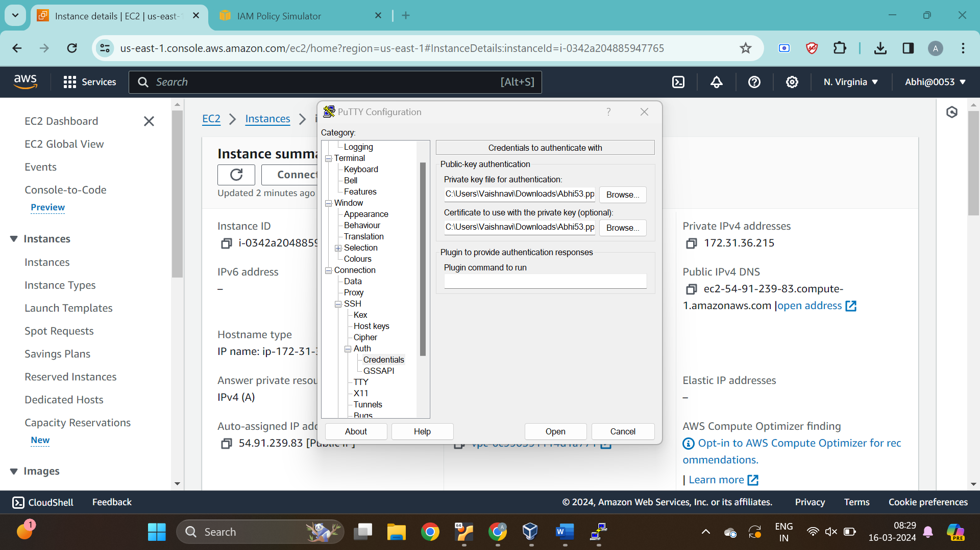

Step 13 : Click on Accept

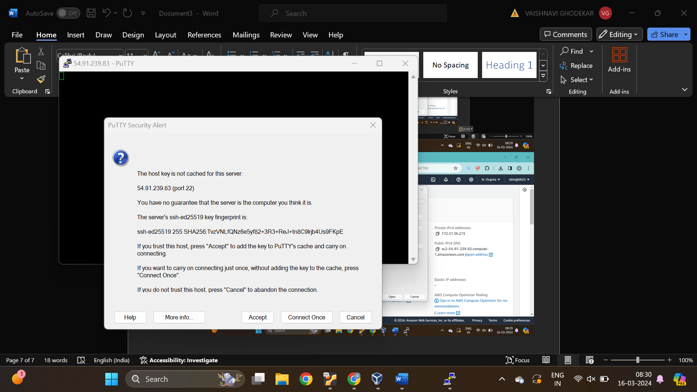

Step 14: The ready window will get open

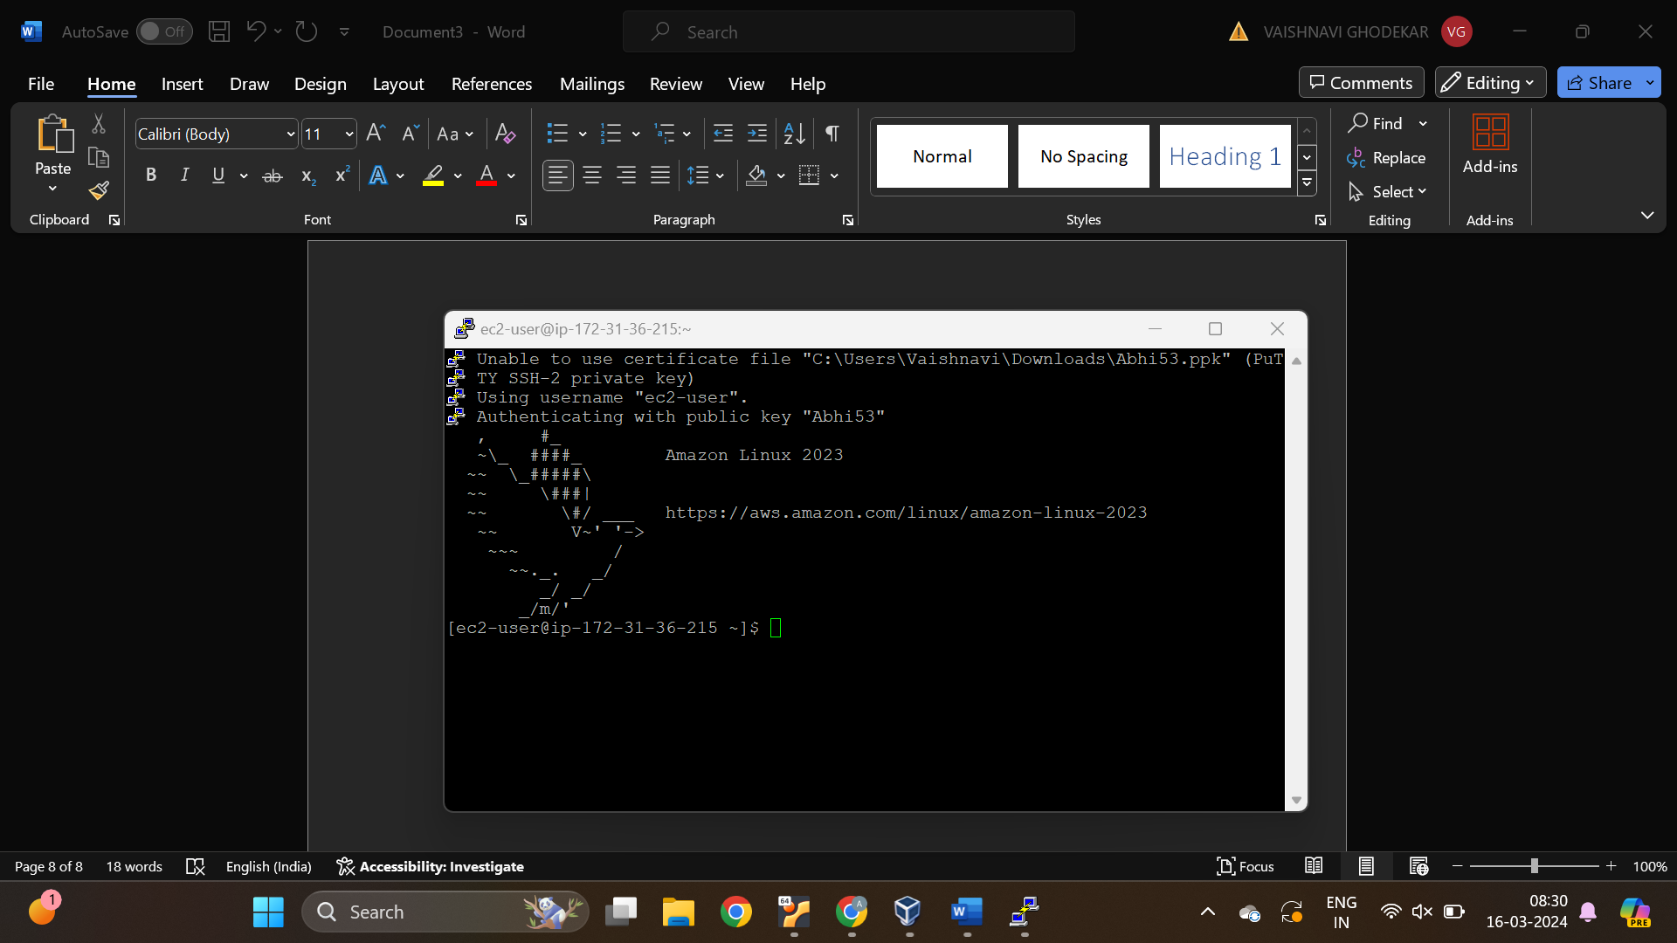

Step 15: Enter Command “sudo -I”

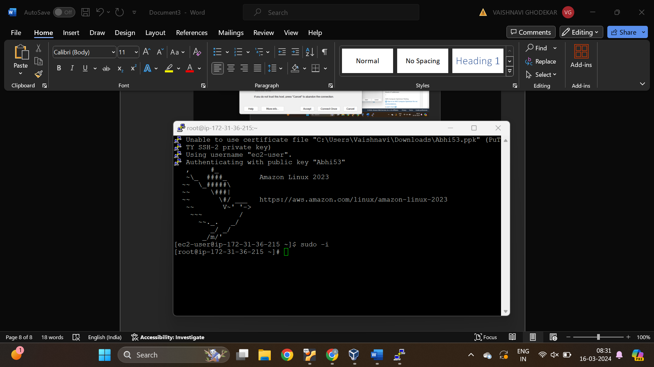

Step 16: Enter Command “Yum install httpd -y”

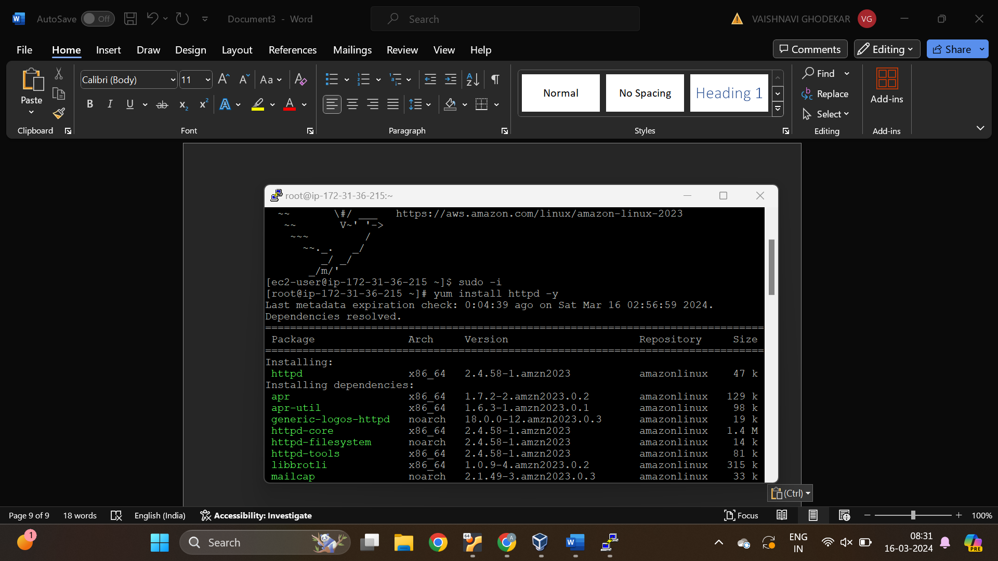

Step 17: Enter Command “systemctl start httpd”

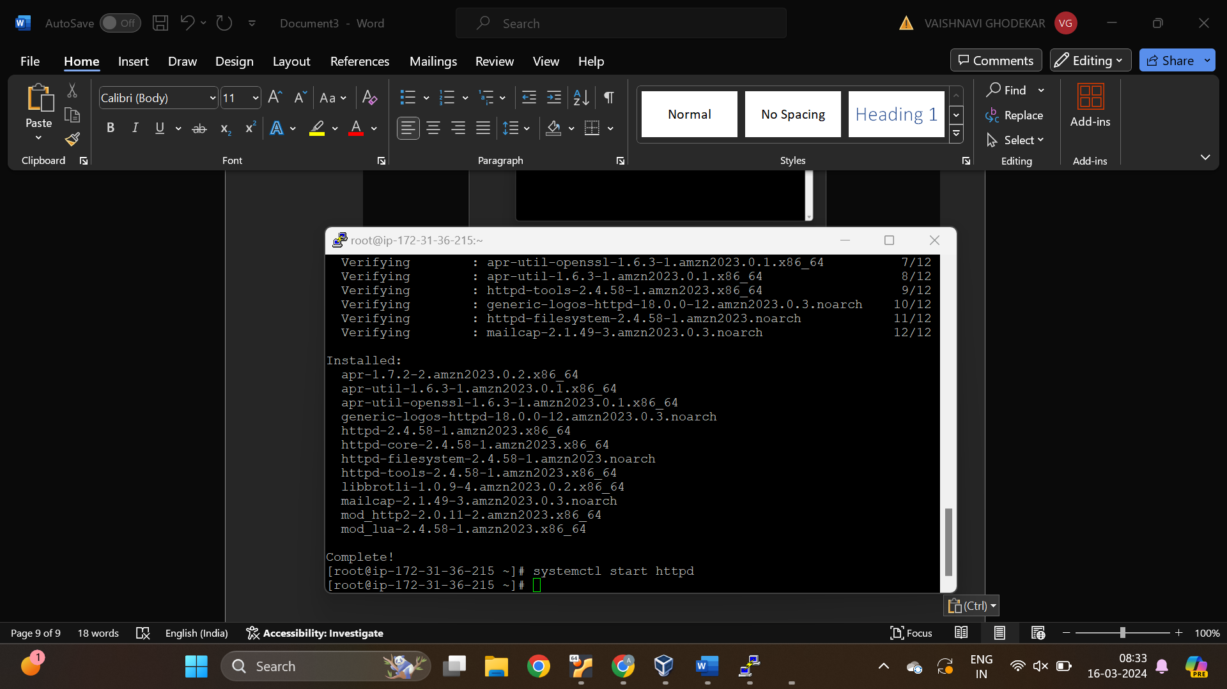

Step 18: Enter Command “sysytemctl status httpd”

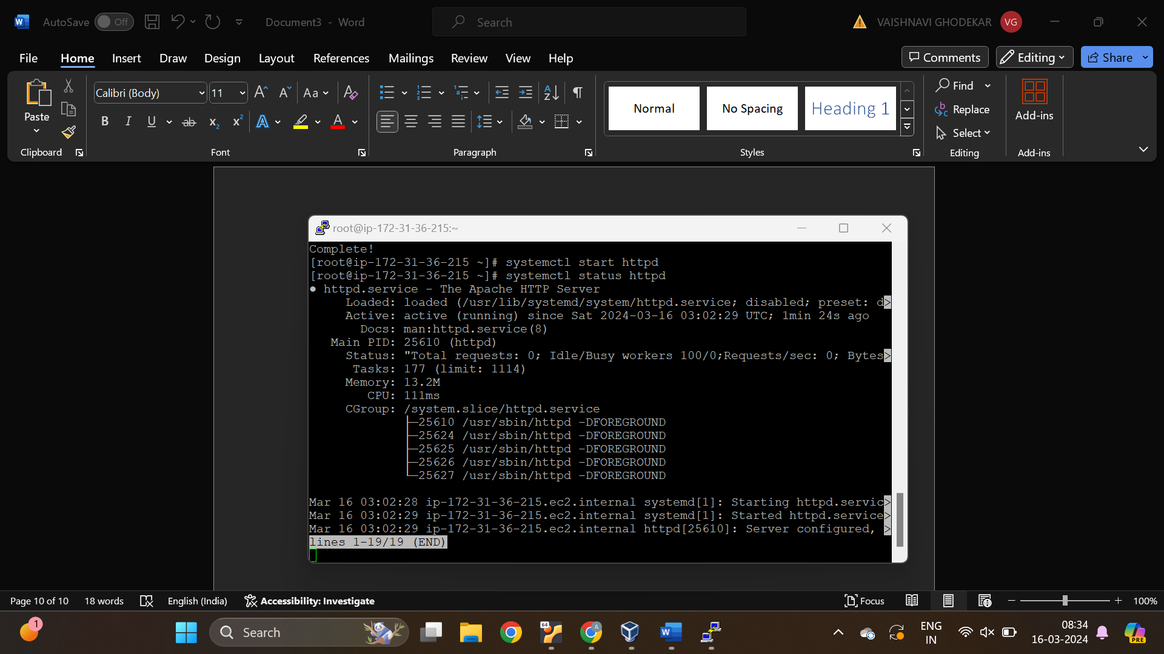

Step 19: Enter Command “ systemctl enable httpd”

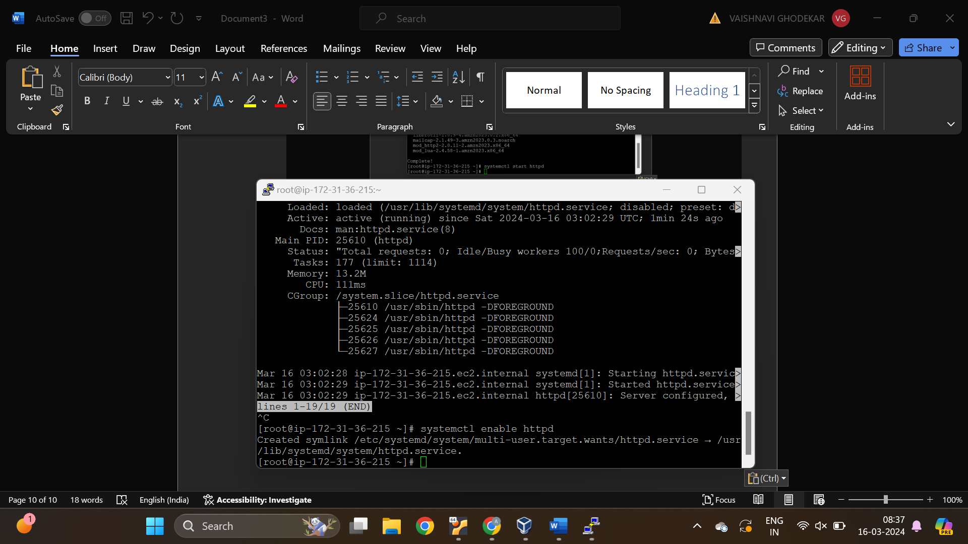

Step20: Enter Command “ cd /var/www/html”

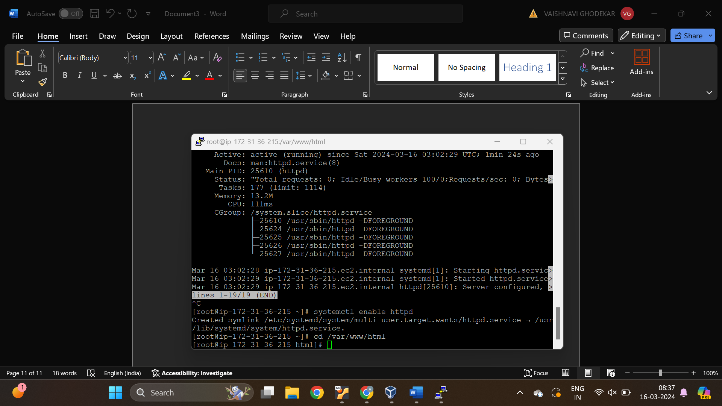

Step 21: Enter the message in index.html filem which we have to show

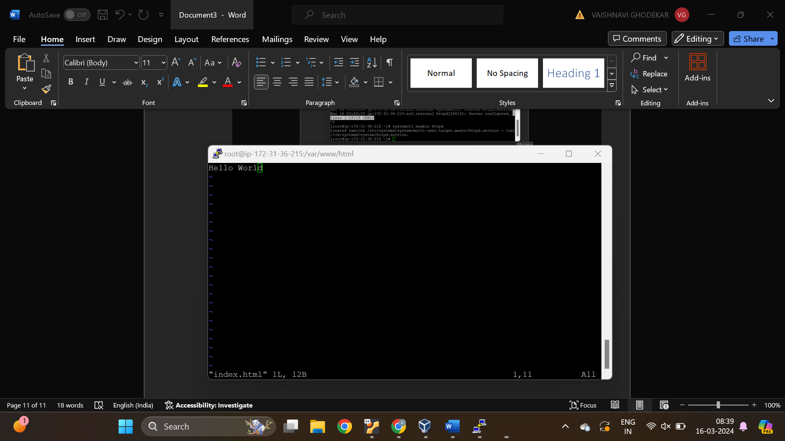

Step 22: Check the message with cat command

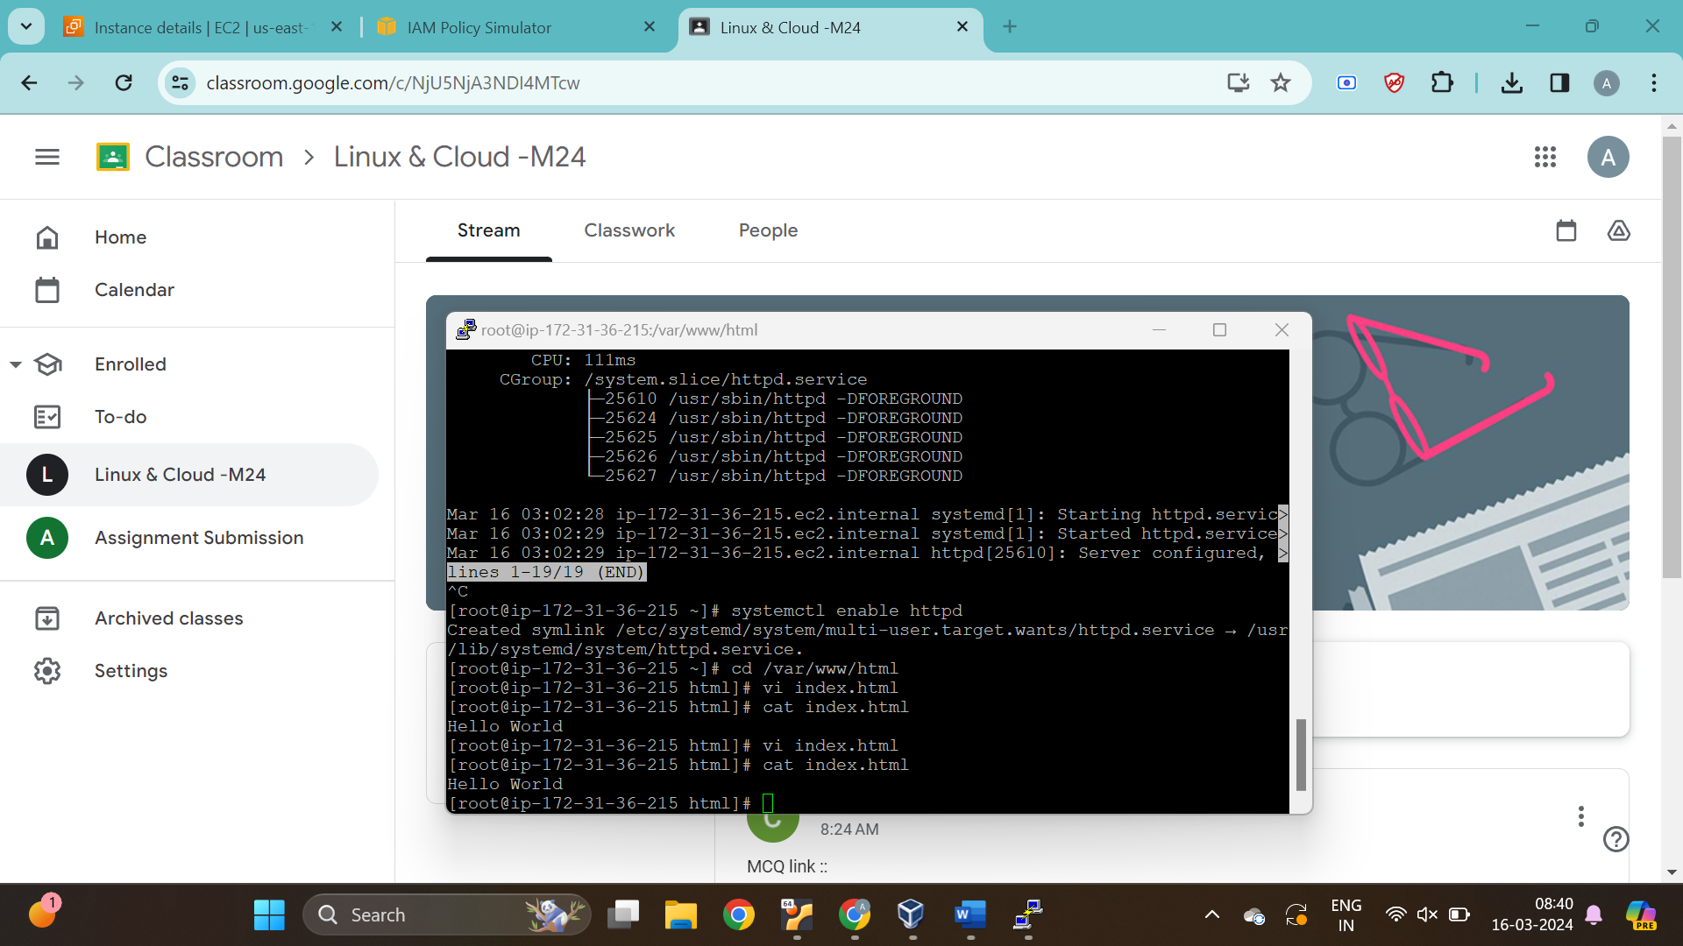

Step 23: Copy the Ec2 instance Ipv4 address

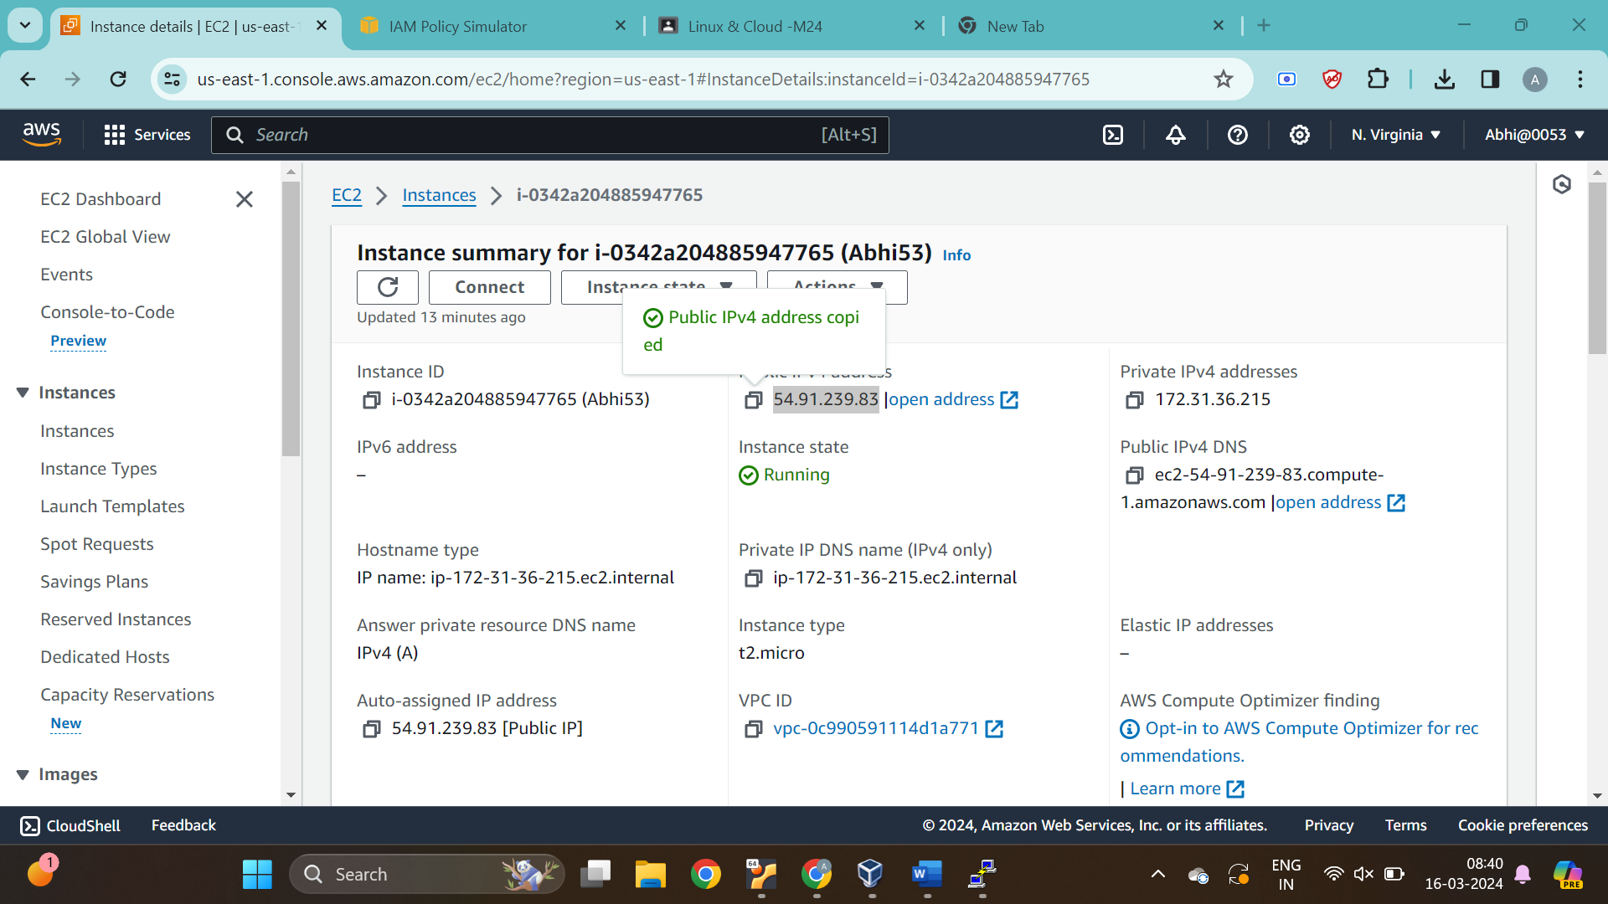

Step 24: Enter the address in the search engine to see the output

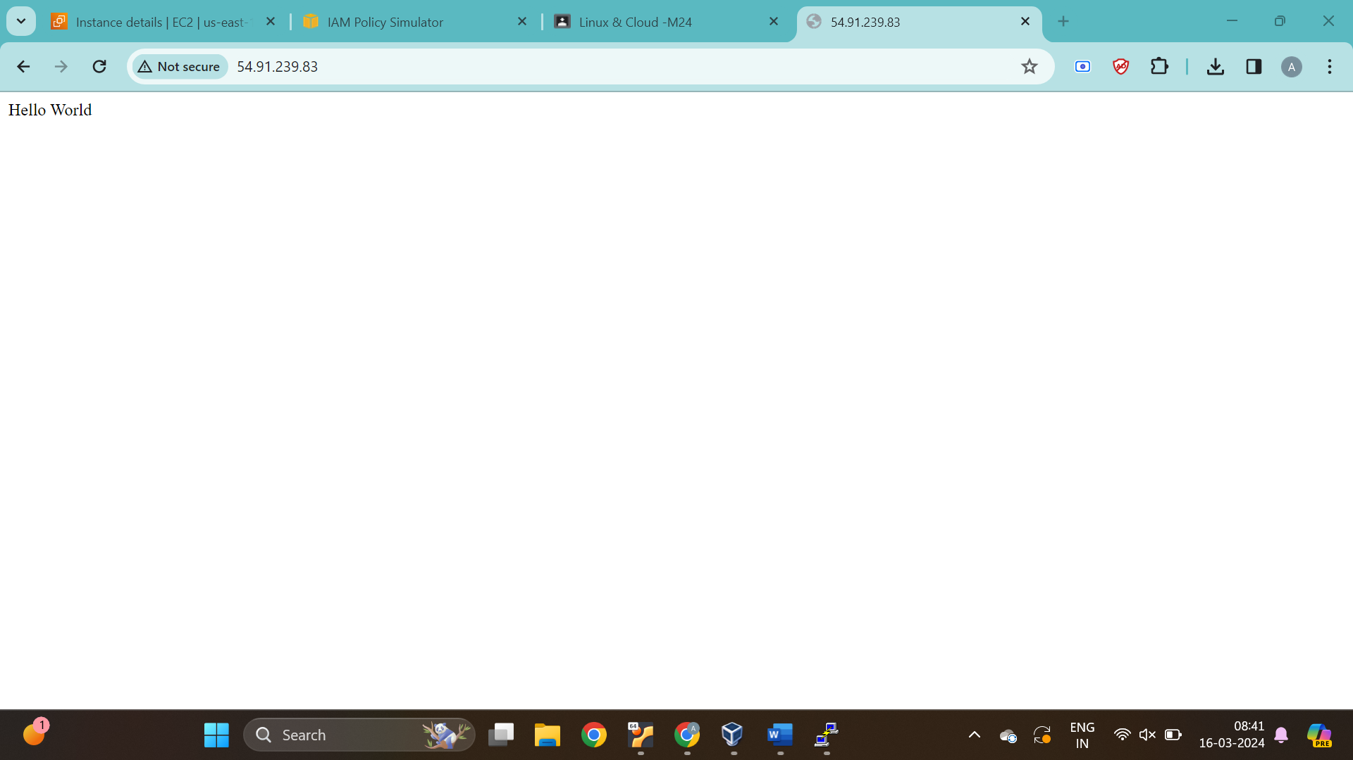

Question 2:

Step 1: Open S3 bucket Console and Click on create Bucket

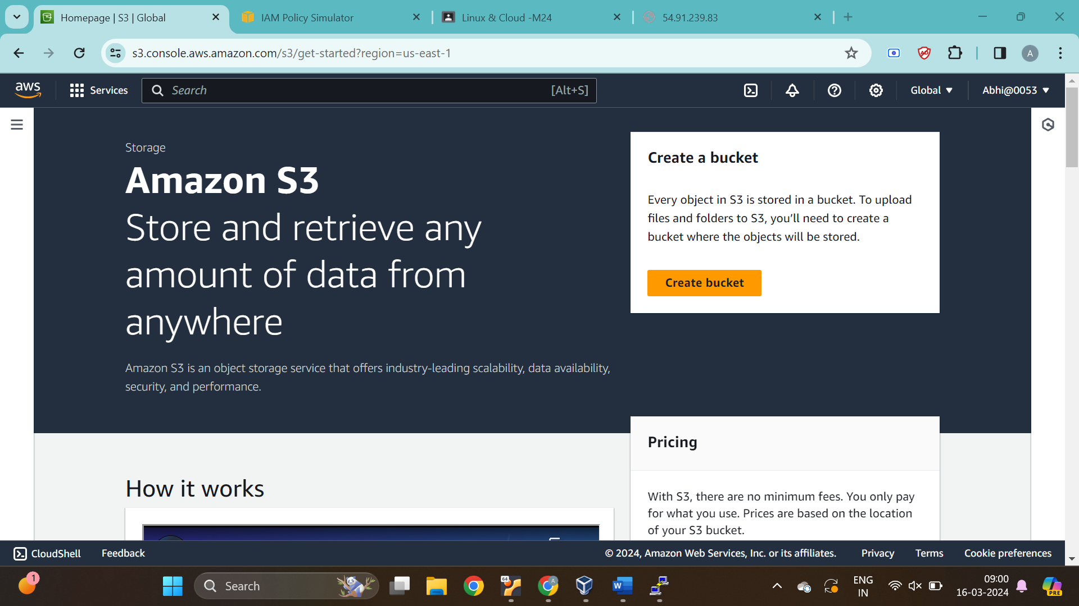

Step 2: Enter the Backet name that should be universally available

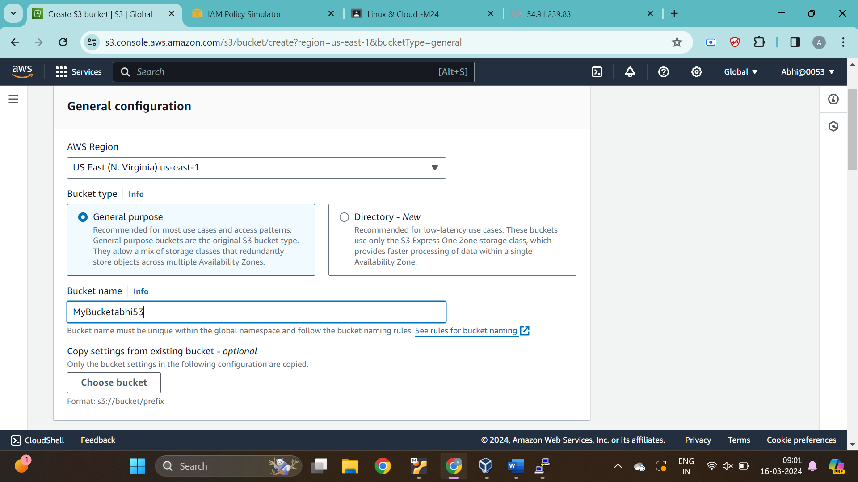

Step 3: Click on ACLs Enabled

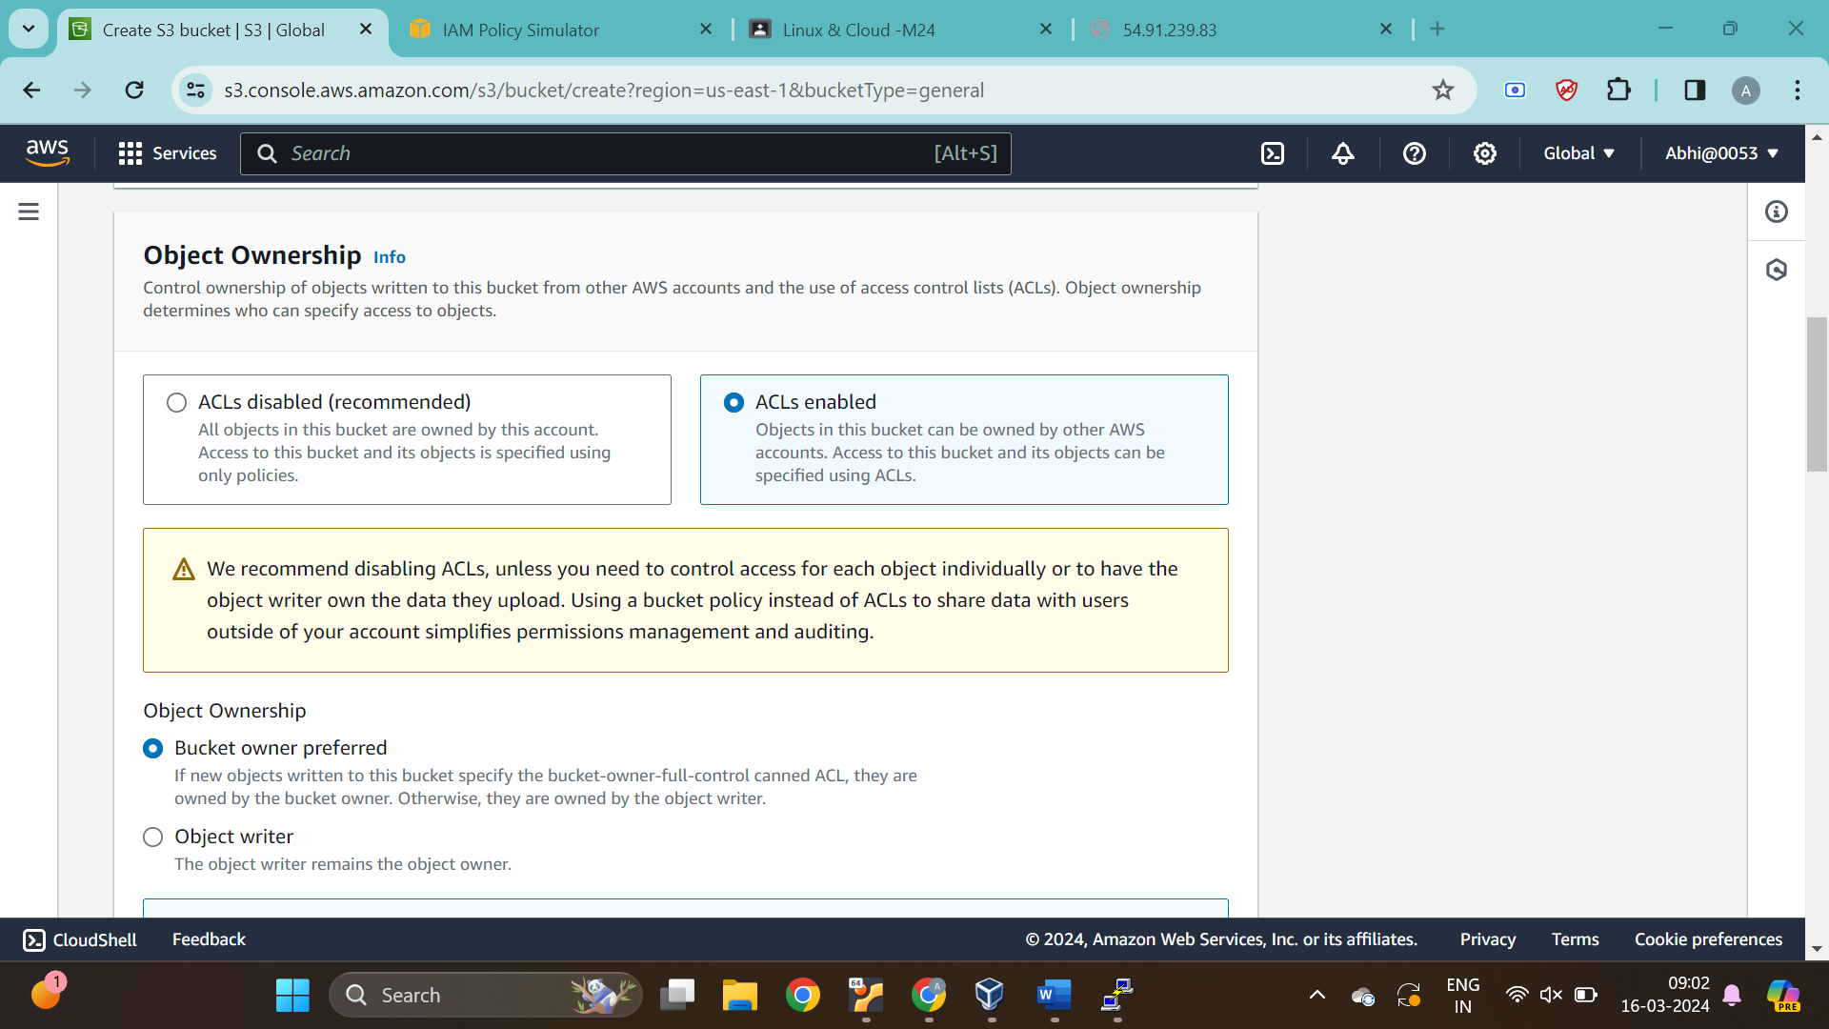

Step4: Untick the Block all pulic access box

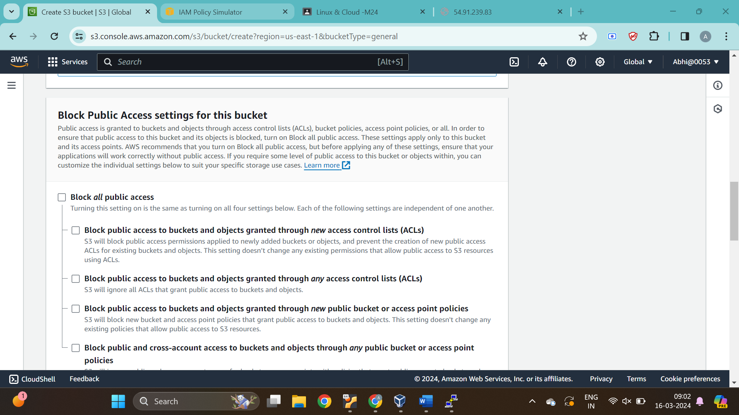

Step5 : Enable the Bucket KEy

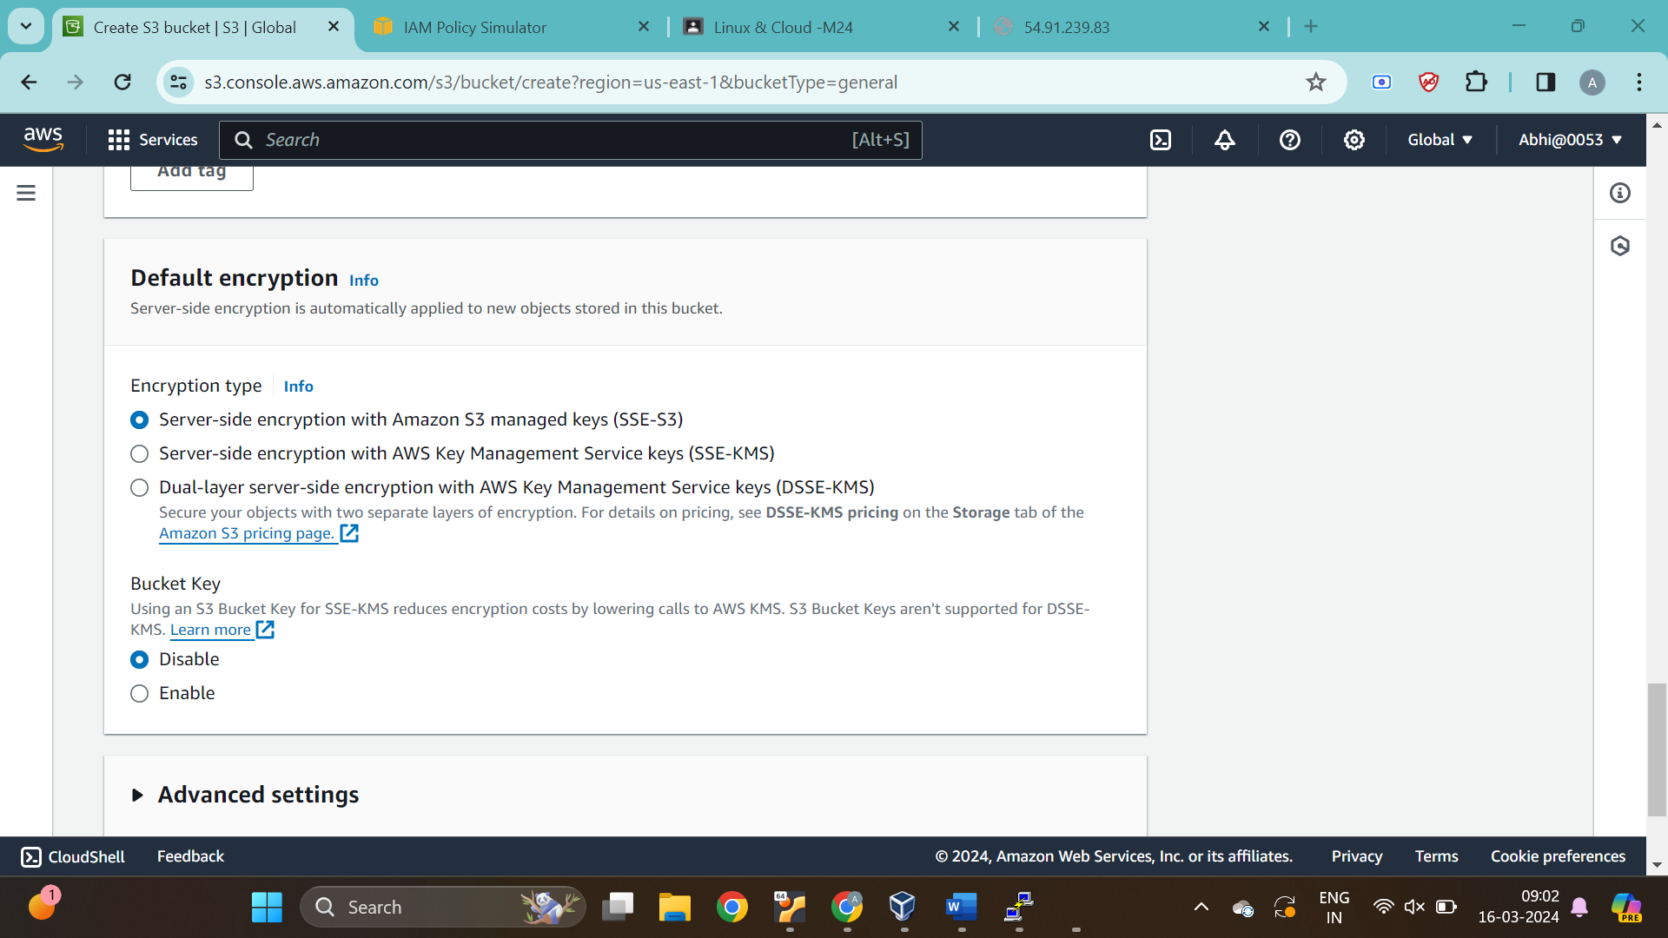

Step 6: Click on the bucket name

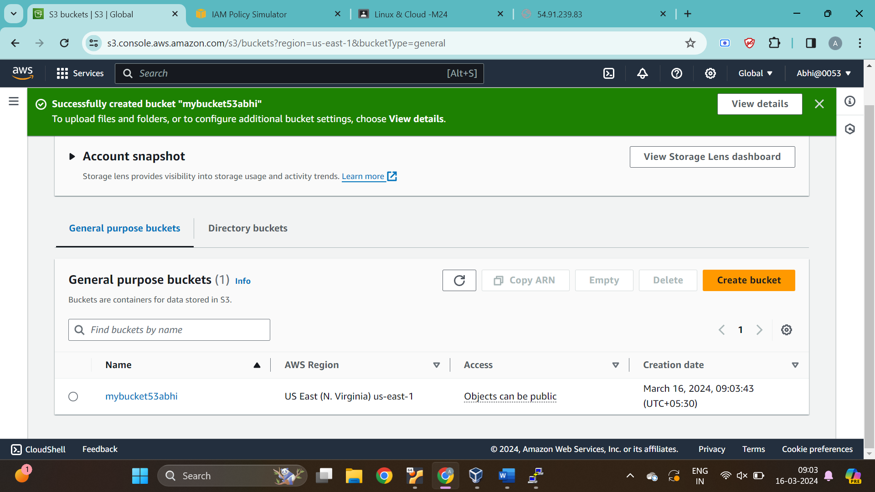

Step 7: Click on upload to upload files

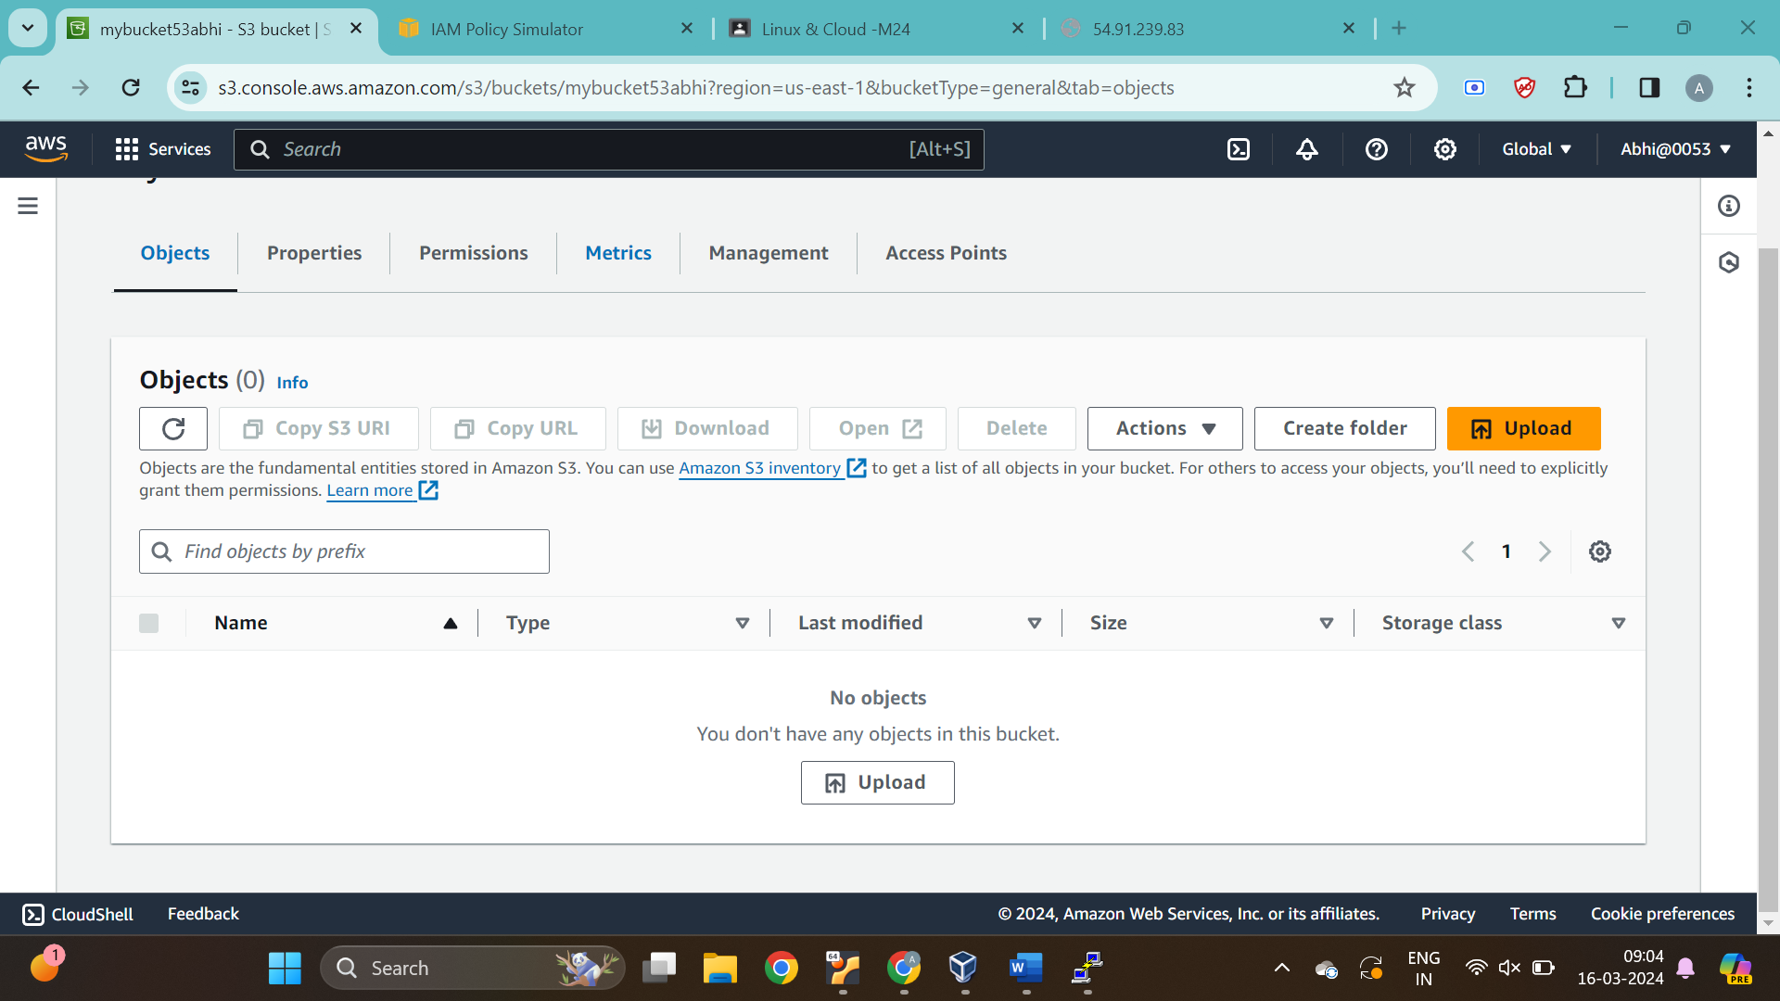

Step 8: Select the file to be uploaded and click on upload

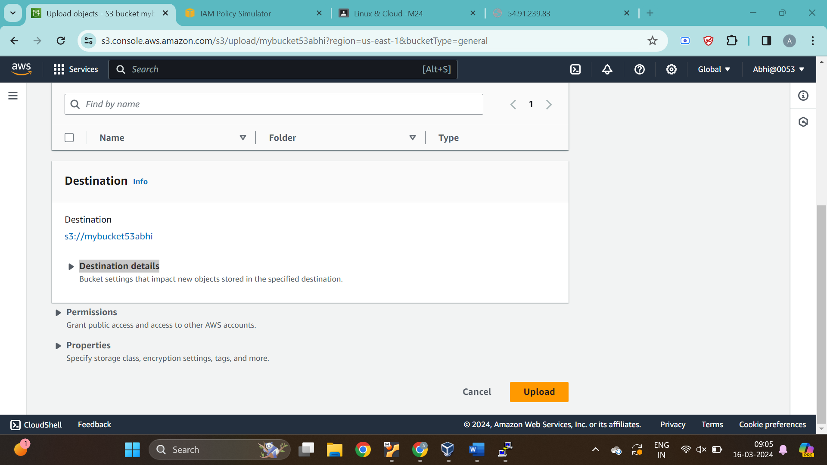

Step 9: Click on image name

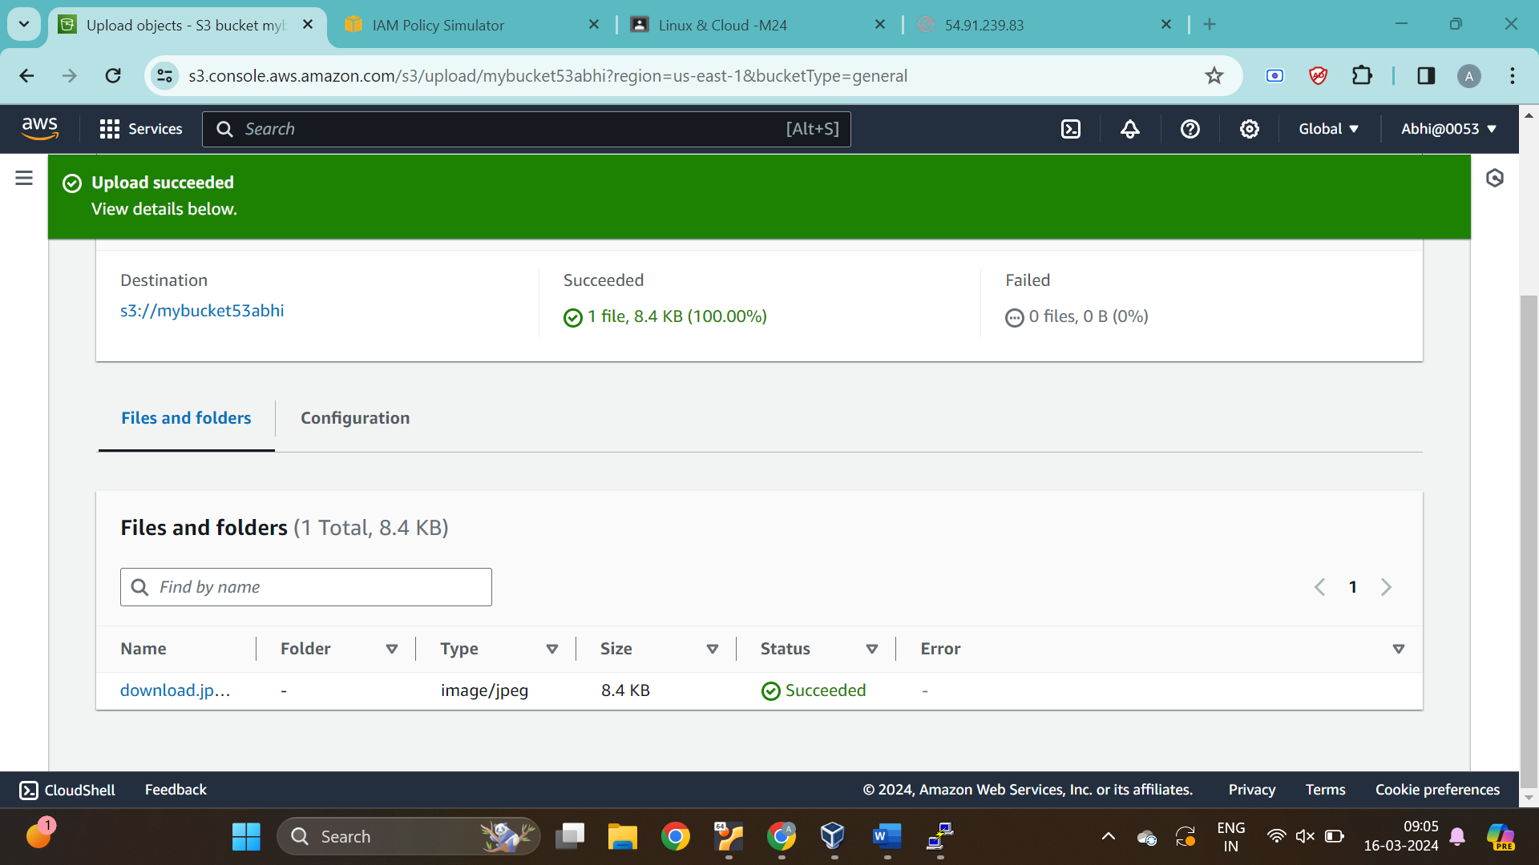

Step 10: Click on permissions

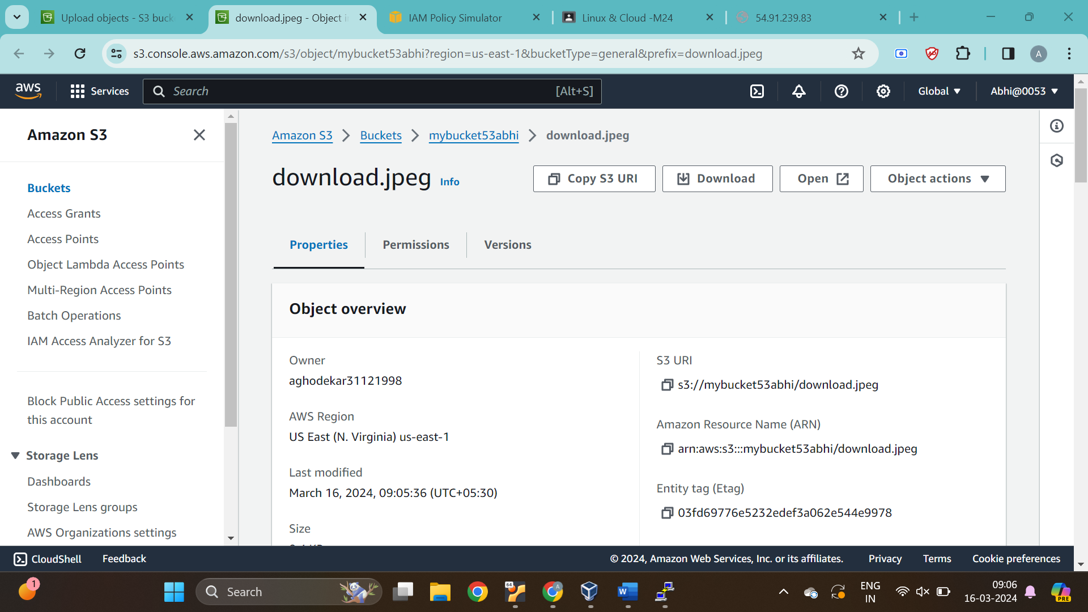

Step 11: Click on edit button and tick all the read tick boxes

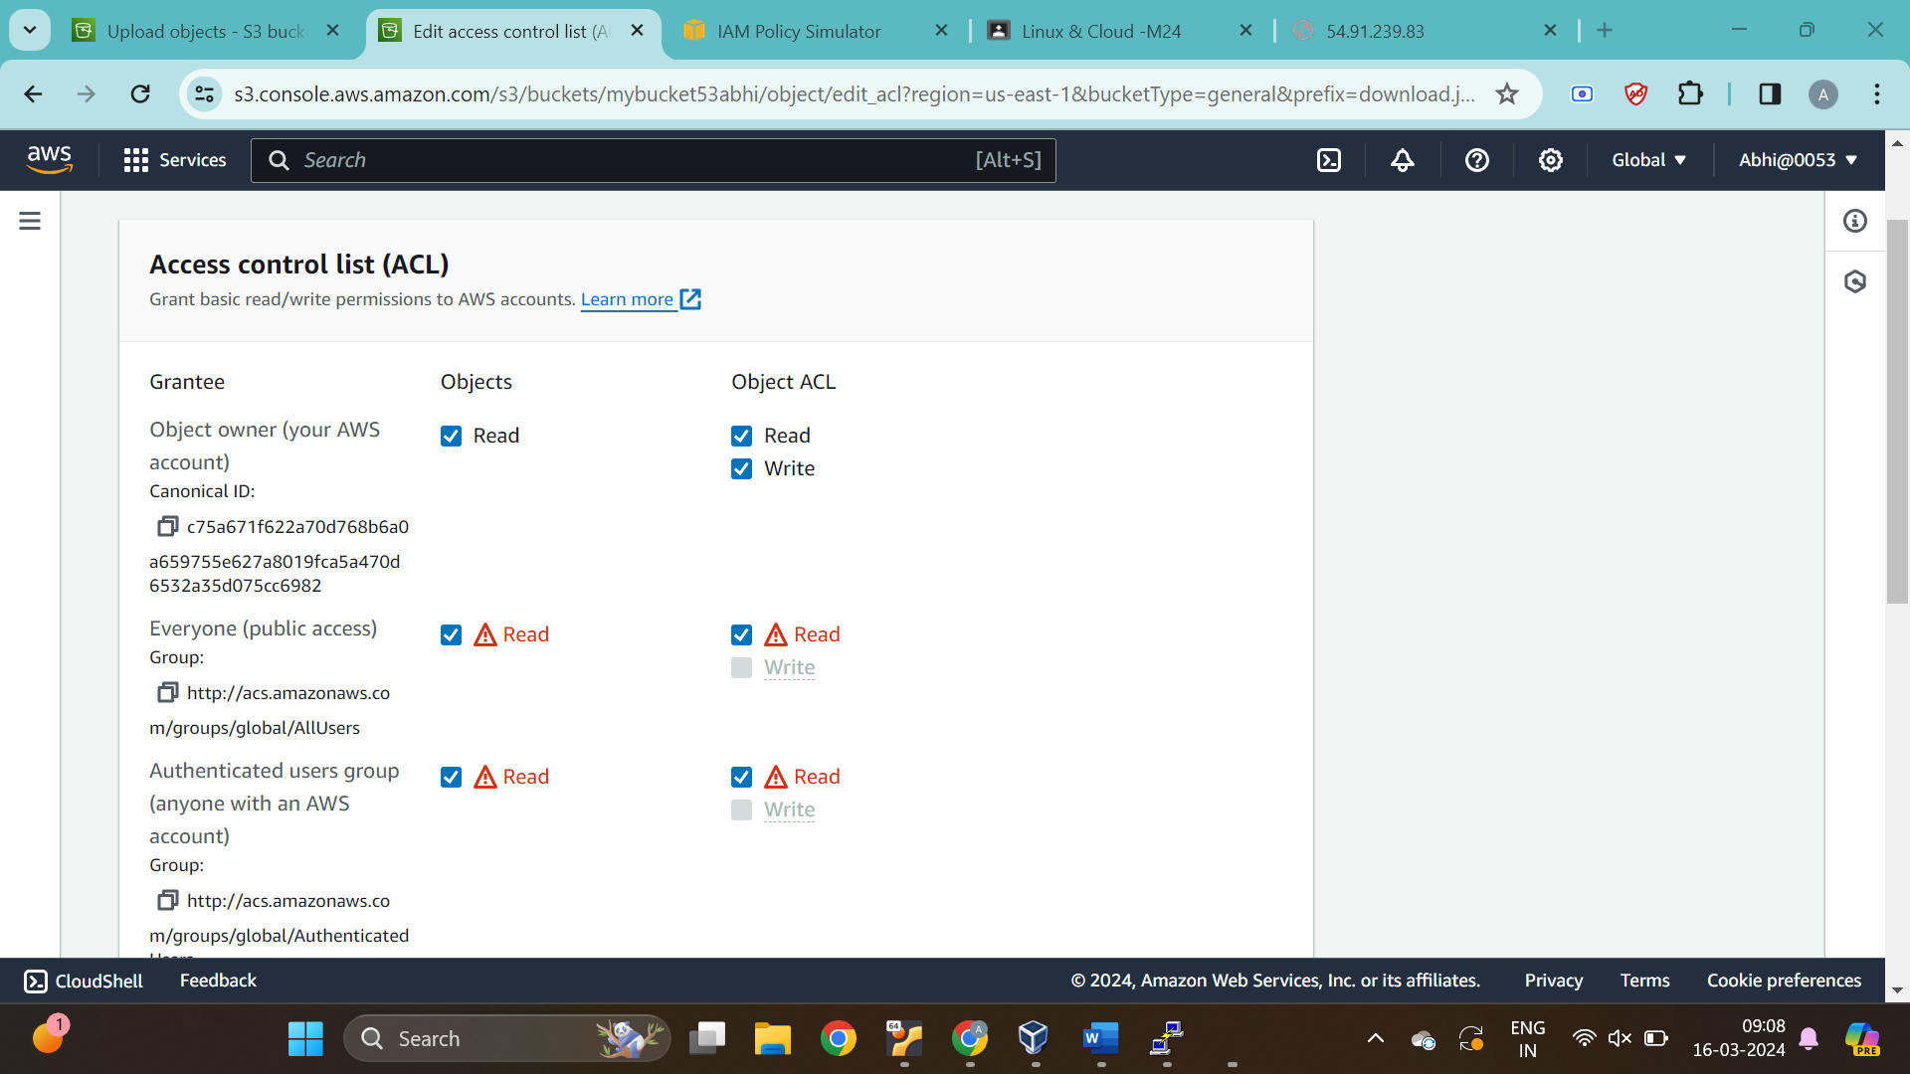

Step 12: Click on save changes

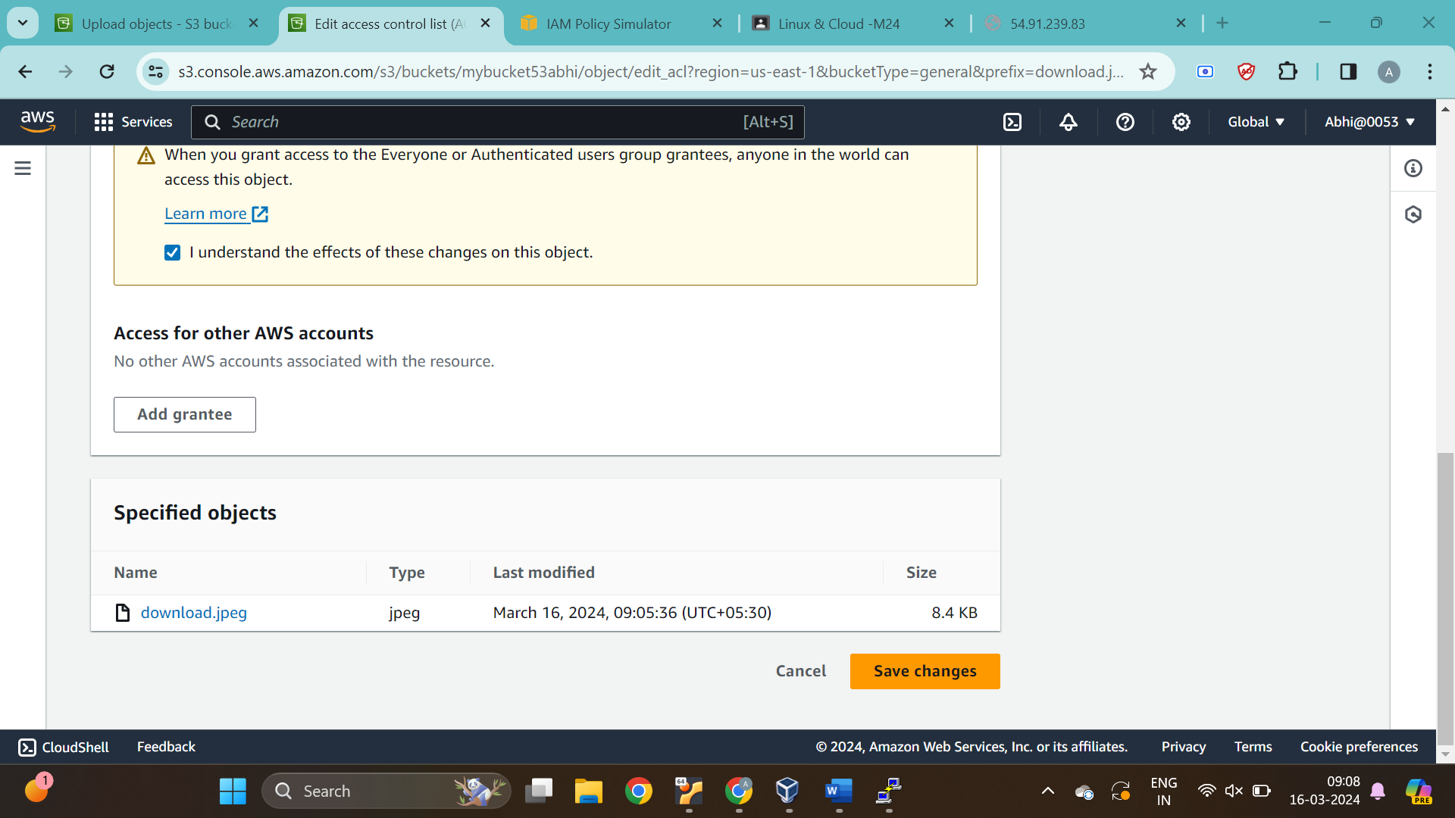

Step 13: Copy the Object URL from image details

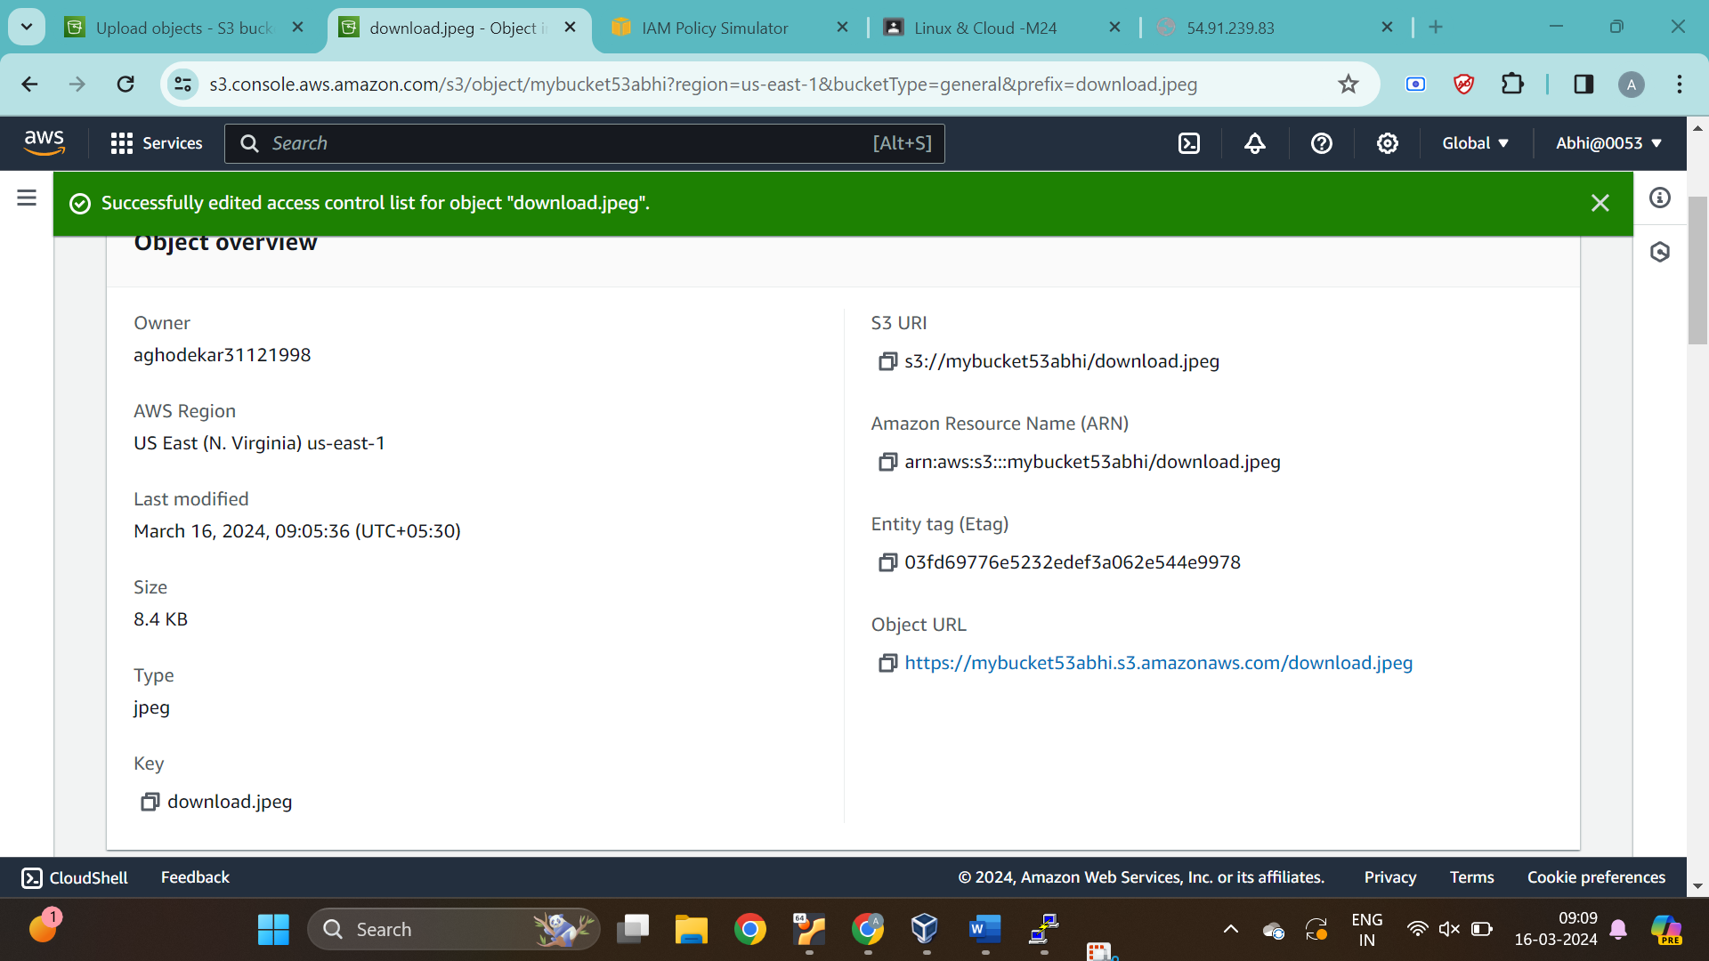

Result:

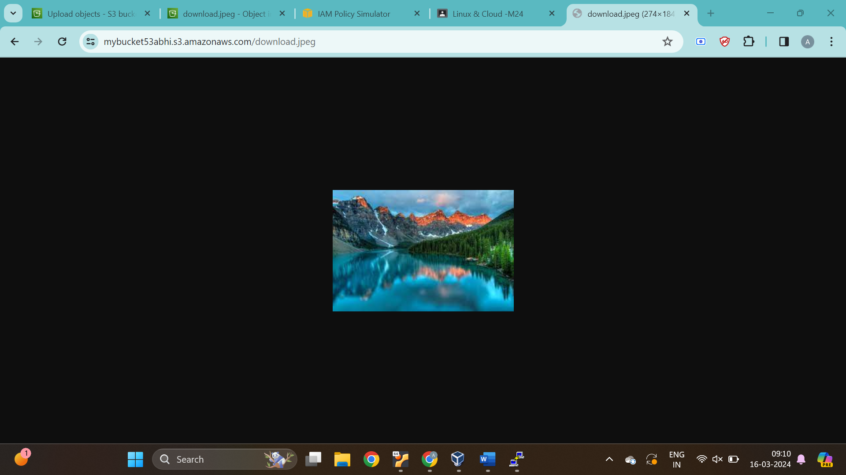

Q3

* Create a new directory with specified name
* Rename an exixting directory with a new name

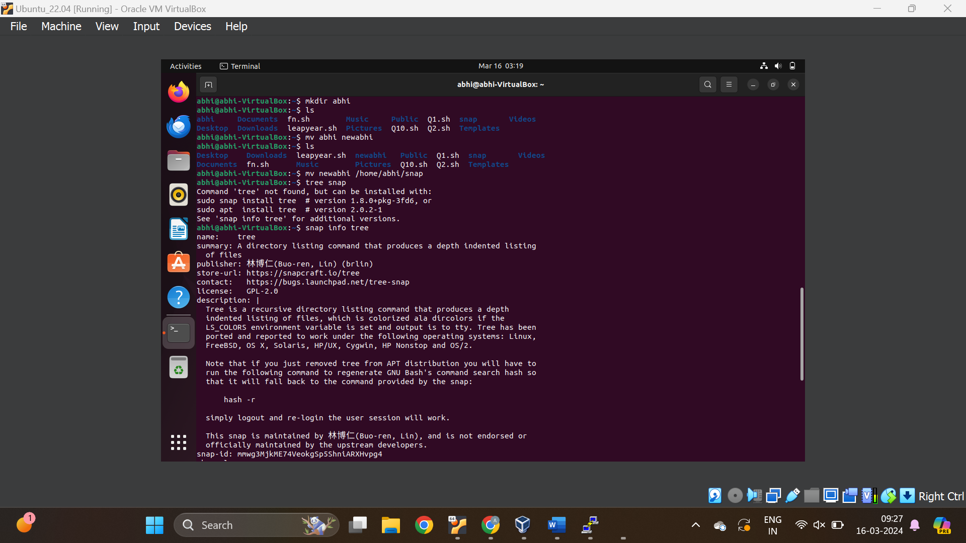

* Move an exixting directory to a new location

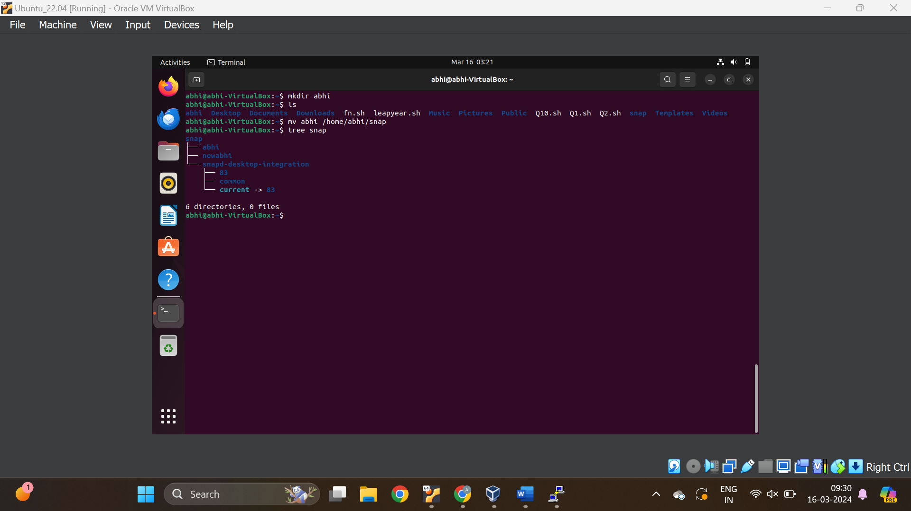

Create a new file in a specified directory with a specified name and give read write permissions to user and group

